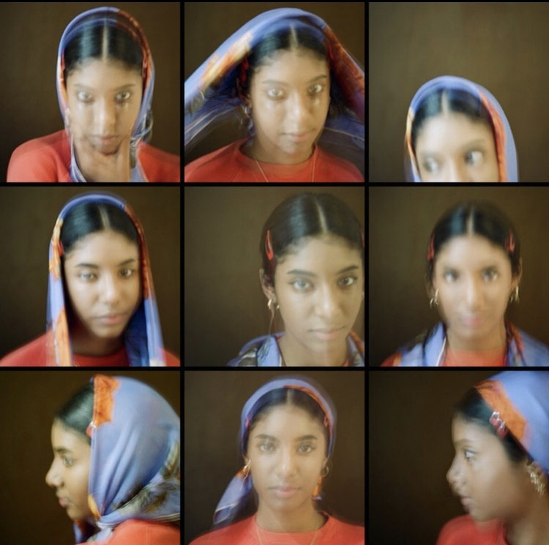

Film photography has really impacted Boothe’s journey within photography; ‘When I started film photography, everything changed, I felt like I had a purpose to shoot’. Studying photography can sometimes seem dire and you don’t always get the creative freedom you expect. The transition from digital to film was a big step in Boothe finding her eye as a photographer which benefitted her exploration in ideas.

I don’t know if I’ve met anyone who screams East London as much as Poppy Boothe. In our discussion on growing up working class and in London, Boothe expressed how different her work would be if she hadn’t grown up in London. ‘Shooting London is unintentional, I’m from London so this is what I see, if I were to grow up in the middle of nowhere, my work would be very different’. We further discussed the importance of being in a city with a range of people in it. As artists, it’s easy to find inspiration through variation. Even being from Romford, Poppy claims to have understood how the city works and what she shoots of it is nothing other than her perspective on London.

We stepped upon a conversation regarding the creative community in London. More specifically the effect social media has on the community. In many ways social media benefits artists especially when it comes to networking. However, Boothe has mixed opinions. On one side social media can make you doubt your work and compare yourself and at the same time it can be influential and inclusive; ‘you can post work and as soon as you refresh, there is someone else’s work...social media can make you doubt yourself but it is also a great place to find inspiration’. A s a Londoner, Boothe has come in contact with many who are in the arts and was also lucky enough to have had friends going in the same artistic direction.

The talk about direction in artwork made me curious about Poppy’s process when shooting. She has a mixture of photo styles, shoots and the pictures taken in a moment; ‘sometimes I just take my camera everywhere or I will do a shoot when I’m at a friend’s house’. Boothe has the intention of making her viewers feel anything from sad to happy to nostalgic to simply just feeling like they want to be in whatever they are seeing. Vivid colouring is important as seen in many of her photos. She told me how she’s always been interested in things visual, and with that, colour comes as key for her

Boothe is currently considering making a photo book but also expressed the importance of enjoying how things are at the moment. Young artists tend to over think, which is okay as well, we agreed on that. However, for now Poppy Boothe is always shooting her city and the individuals that make it what it is.

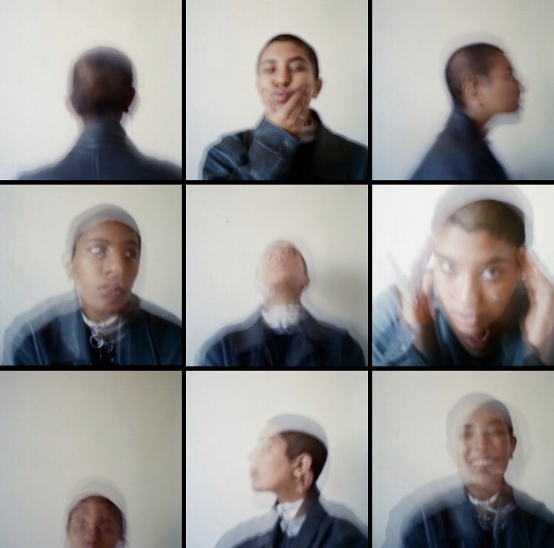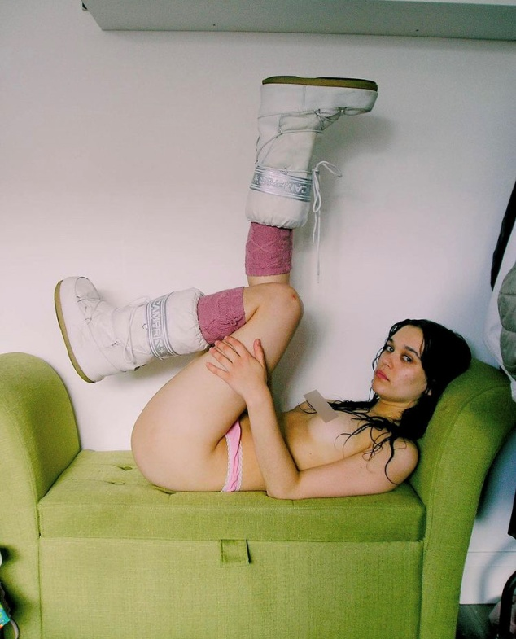

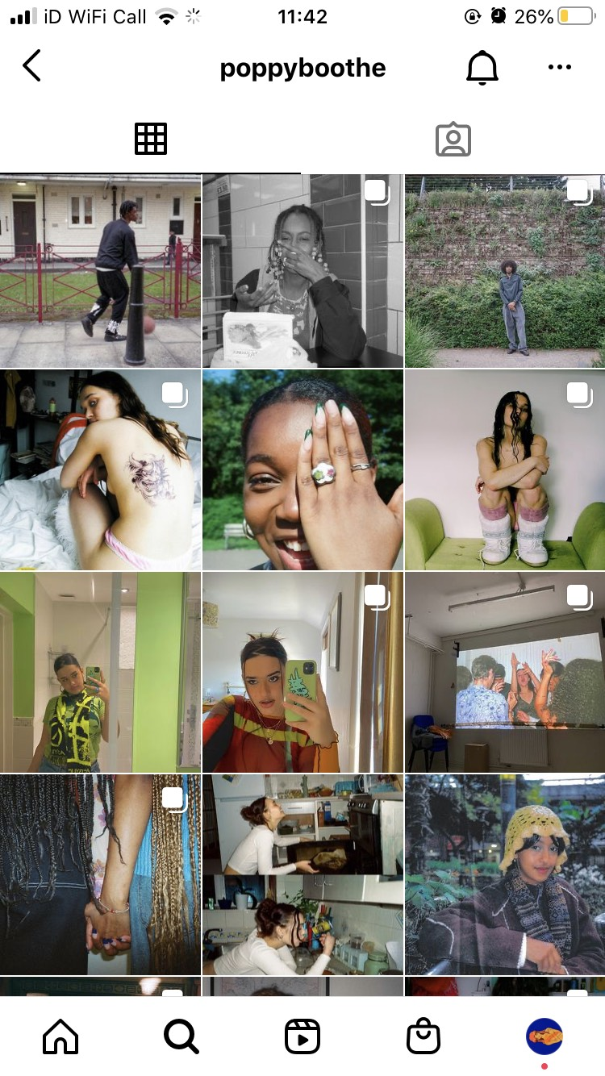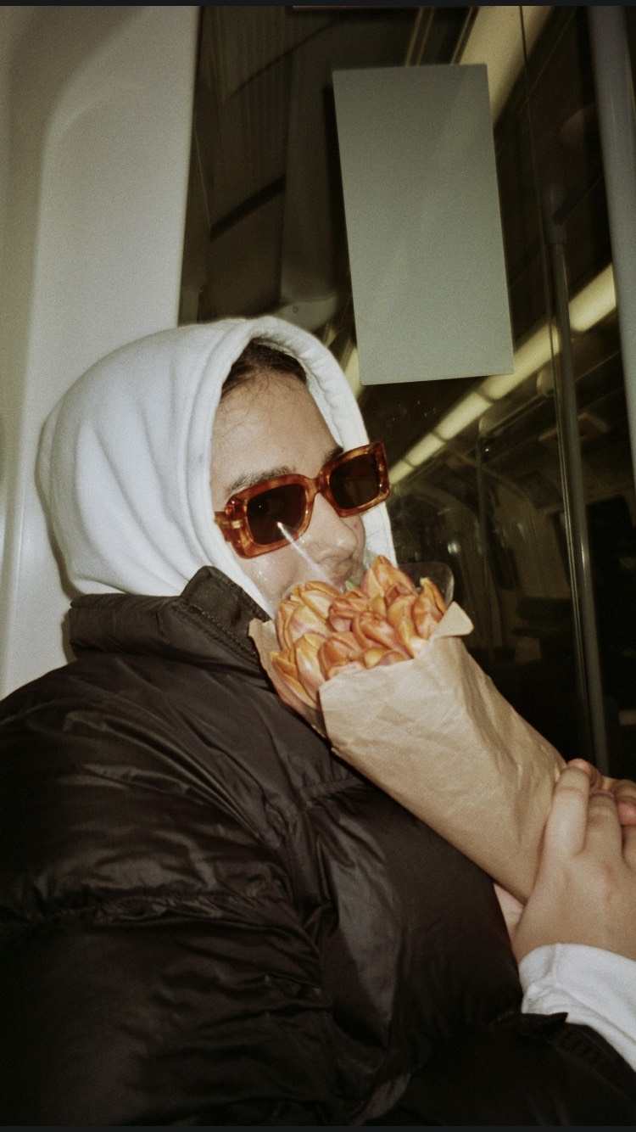

Poppy Boothe, 19, is an East London born, South London based photographer determined to make people want to be in the photos she takes. In my conversation with Boothe, we had discussed family influence, the importance of people in art and life, the current state of the creative community in London and what it truly feels like to be a young photographer in the city in 2021.

Growing up in Romford, East London, Boothe had uncovered many major influences in her upbringing We spoke about main influences, she had mentioned how the significant role her parents had in how she views arts; ‘my parents had always surrounded me with art, from the music my father made to my mother taking us to free art exhibitions as a kid’. Boothe has always carried a do it yourself attitude. Being raised to always see things in the perspective of creating something out of nothing has allowed Boothe to use anything at her disposable. People in general play a significant role to Boothe’s work as a photographer, at every step of the creative process. Whether its individuals on social media or friends in and out of the creative community. Boothe has mentioned the importance of people in her work. Even after moving to South London, Boothe claims to look for things in new areas that remind her of home and this mainly works with people she encounters. She claimed ‘if I were to see elderly women on the bus who spoke similar to my grandparents I would want to speak to them or shoot them’. She takes her do it yourself attitude and combines it with work, using what is familiar to create something new while keeping it accustomed to her own style.

Everyone’s journey in their artwork is different. For photographer Poppy Boothe, her journey in photography started at 14, being in year 9 and having photography as an option. Boothe can admit she did not know her style then and still necessarily doesn’t but is comfortable with her work.

IN CONVERSATION WITH POPPY BOOTHE: BEING A YOUNG PHOTOGRAPHER IN LONDON TODAY