Outside of the cinematography and cleverly assembled art direction throughout the film, House of Gucci is a flawed story. It is hard to elaborate where the story is heading. We are presented with a variation of characters and even though the story seems to place Patrizia and Maurizio in the lime light at the beginning, Paulo and Aldo Gucci also have significant time throughout the film. This made me, as well as others at the cinema, rather confused to which perspective we should be experiencing this story through. We are shown a love story, then a family feud and then a murder but in between those crucial points are less crucial moments given the same amount of time. Focusing the film on the death of Maurizio Gucci yet mentioning less pivotal moments as well as characters can be misleading and came off confusing for many. On top of that, the pacing of the film is rather odd. Scott manages to jump from one vital scene to another and for a film that stretches out to two hours and thirty eight minutes, it felt rushed. Towards the end of the film, where it should be detailing how Maurizio is murdered, as that is one of the biggest scandals known in fashion history, it was limited to quiet little time leaving the last scene at the courtroom to be minutes long, while stressing and prolonging other parts of the story that were simply unneeded .

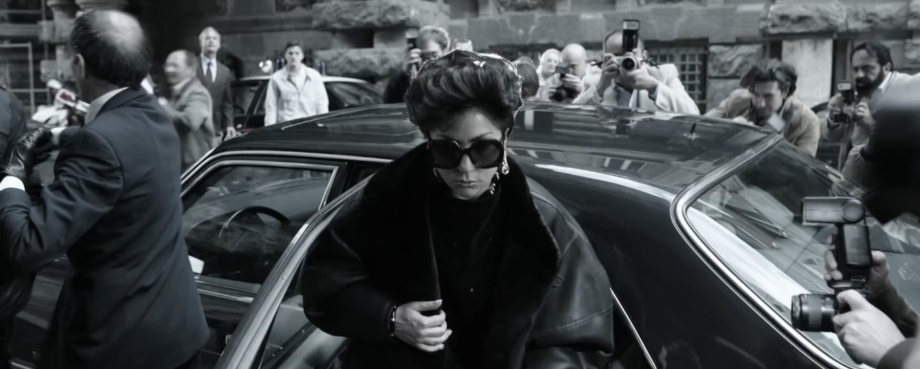HPUSE

The storyline itself is beyond flawed. Member of the Gucci family have already spoken out about their relatives depictions and the misinformation that was presented. There were several family members missed out in the film, most importantly the man who created the brand, Guccio Gucci. There was very little mention of him and almost no mention of his other children; Grimalda, Vasco, Enzo and Ugo Gucci. In addition to the some family members being left out of the film, the lack of accent coaching was definitely seen throughout each performance. Jared Leto’s Italian accent was bordering the line of offensive while Adam Drivers American accent came out at various points throughout the film. Many are still asking why Scott had not casted Italian actors or at the least had a vocal coach on set, it was slightly distasteful as much as it was distracting.

House of Gucci will be remembered as the movie about the Gucci family, whether we will remember the film as a masterpiece depiction of a fashion legacy that still lives on today after years of cheating, crime and murder is still at question for many.

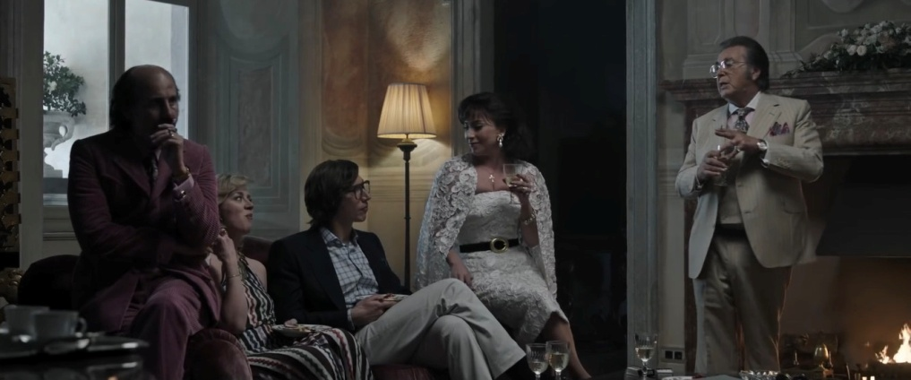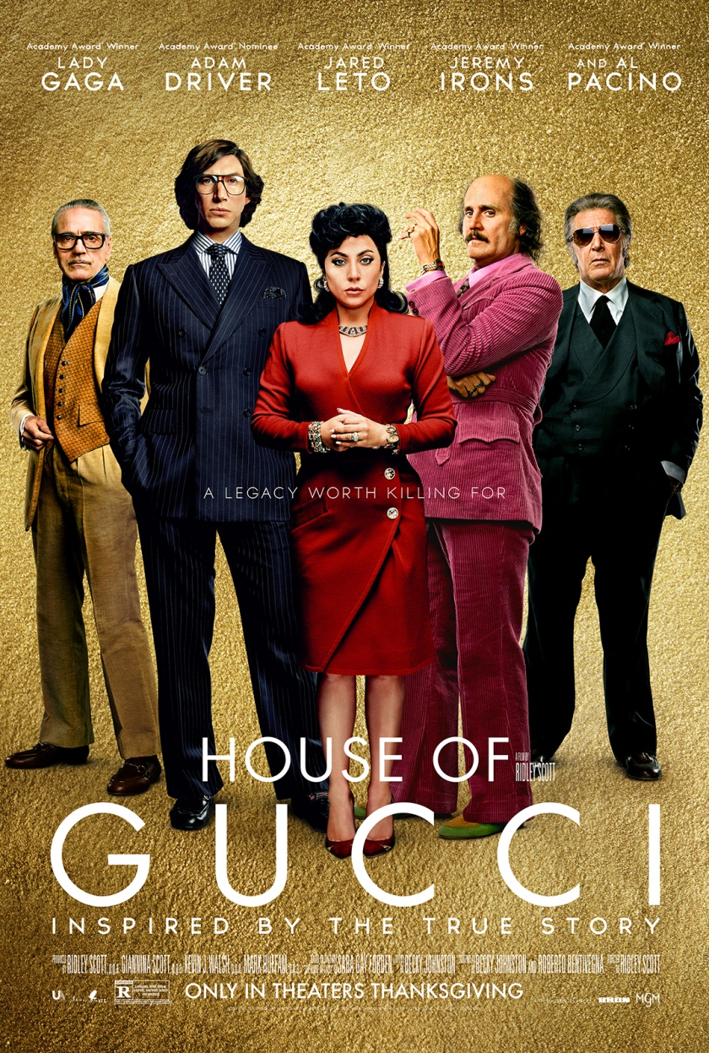

Whilst watching House of Gucci, it is almost impossible to reject one very redeeming quality of the film which is the stunning cinematography. There were several short scenes that replicate Gucci adverts seen in magazines or billboards whilst longer scene still captured the era of fashion as well as luxurious lifestyle that the Gucci’s shared. From the styling of each character to the detail in the set design, House of Gucci is a visual beauty. Art and set directors, Massimo Pauletto, Saverio Sammali and Christina Onori presented a visual concept that suited Gucci as a brand and how many audience members would see the fashion label which is important, at the end of the day this is a film about one of the biggest fashion houses of the 20th century.

The 2021 film House of Gucci, directed by Ridely Scott and based off the book of the same name written by Sara Gay Forden, depicts the chaos around the Gucci family and legacy. Scott attempted at capturing the murder, greed, romance and family feud through the several characters and plotlines within the film. However with the stunning cinematography, styling and star cast, what about House of Gucci failed in executing a depiction of such a scandal in fashion history?

The film starts off with a simple love story. We are introduced to Patrizia Reganni, later know as Patrizia Gucci, a lively and excitable working class young woman. In 1978, Patrizia, who is played by Lady Gaga, is seen working as an office manager for her father’s trucking firm, around the time she meets Maurizio Gucci at a party in Milan. Maurizio, played by Adam Driver, is a montone and shy law student at the beginning as well as the heir to half of the Gucci label. House of Gucci takes us on a trip through their romance for almost the first half of the film. From Maurizio’s father, Rodolofo Gucci who is played by Jeremy Iron, disowning him after meeting Patritzia, to Maurizio’s death that Patrizia ordered. We are also introduced to other members of the Gucci family, Aldo Gucci, played by Al Pacino, Maurizio’s uncle who is swindled out of shares in Gucci and goes to prison for tax evasion. His son Paolo Gucci, who questionably played by Jared Leto, who is made a joke by his family for his camp style and taste.

HOUSE OF GUCCI – THE DISASTER IN THE DRAMA